

VISVESVARAYA TECHNOLOGICAL UNIVERSITY, BELAGAVI - 590001
A Report on
“SmartLIB”
(A Project-Based Learning)
(Subject code: 1BIDTL158)
Bachelor of Engineering
in
“Computer Science”
Submitted by
Name: Manthan T Patel
Roll No: A27
USN: 2JH25CS061

Under the guidance of
Prof. Somashekar T M
Assistant Professor
Department of ME


JAIN COLLEGE OF ENGINEERING AND TECHNOLOGY, HUBBALLI-580031

2025-26


JAIN COLLEGE OF ENGINEERING & TECHNOLOGY
404/4/5, Hebballi Road, Sainagar, Unkal, Hubballi-580031

DEPARTMENT OF BASIC SCIENCE

CERTIFICATE
It is certified that report entitled “SmartLIB” is a bonafied work carried out by _______________________ bearing USN ______________ of First semester, prescribed by the Visvesvaraya Technological University, Belagavi during the year 2025-26. The report has reached the standards fulfilling the requirements of the regulations related to the course.

Guide Head of Department Principal
Mr. Somashekar T M Dr. Adarsh K S Dr. Prashanth Banakar

Name of the Examiners Sign
- Internal Examiner: ______________________ _______________
- External Examiner: ______________________ _______________

ACKNOWLEDGEMENT

I, Manthan T Patel bearing the USN 2JH25CS061 would like to thank our Principal, Dr. Prashanth Banakar, who gave us this opportunity to conduct the Innovation and Design Thinking activity project on, “SmartLIB ”.

I would also like to thank our HOD, Dr. Adarsh K S, and our project Guide, Mr. Somashekar T M, for giving us the right guidance in initiating this activity.

Student Signature

Signature: ____________
Date: ____________

INDEX
Sl. No | Contents | Page no
1 | INTRODUCTION | 2
2 | LITERATURE SURVEY | 3
3 | SYSTEM REQUIREMENTS | 5
4 | SYSTEM DESIGN | 6
5 | IMPLEMENTATION | 8
6 | RESULTS AND OUTPUT SCREENS (DETAILED) | 9
7 | TESTING | 11
8 | ADVANTAGES, LIMITATIONS & APPLICATIONS | 12
9 | CONCLUSION AND FUTURE ENHANCEMENT | 13
10 | REFERENCES | 14

ABSTRACT

SmartLIB is a comprehensive solution designed to automate the operational workflows of college libraries. In an era of rapid digitization, the project addresses the inefficiencies inherent in manual library management, specifically in seat allocation and book circulation. The system is built using a modern decoupled architecture, utilizing React 19 for the frontend and Supabase (PostgreSQL) for the backend. The development followed an innovative AI-Augmented SDLC, leveraging Gemini, Claude, and Antigravity to ensure precision in logic and excellence in UI design. The final system includes a functional AI-powered book recommendation engine that suggests titles based on student academic profiles. The final outcome is a high-performance web application, also distributed as an Android APK via Appilix, which provides real-time seat tracking, multilingual support, and secure administrative control.

CHAPTER 1: INTRODUCTION

Background of the Project
Library management remains a critical backbone of academic institutions. However, the surge in student populations has made manual management of resources—especially reading room seats—highly chaotic. SmartLIB was conceived to bring order to this process through a unified digital interface.

1.2 Problem Statement
Current library workflows suffer from:
- Lack of real-time seat availability visibility.
- Manual verification of student IDs for book loans.
- Inefficient handling of overdue fines and reservations.
- Linguistic barriers for students comfortable in regional languages.

1.3 Objectives
- To automate seat booking with real-time status updates.
- To provide a searchable digital catalog with reservation capabilities.
- To implement role-based access for Students and Librarians.
- To support English, Hindi, and Kannada languages.
- To implement an automated recommendation system for academic resources.

1.4 Scope
The scope includes user registration, secure authentication, interactive floor maps, inventory management, and fine calculation. It covers both web and mobile access via a single codebase.

CHAPTER 2: LITERATURE SURVEY

2.1 Introduction
A literature survey is conducted to study existing library management systems, digital seat allocation methods, and recommendation-based academic platforms. This study helps in understanding current technologies, identifying limitations, and proposing improved solutions. Various research papers, institutional systems, and commercial platforms were analyzed during this phase.

2.2 Existing Library Management Systems
Traditional library management systems primarily focus on book inventory and circulation. Most systems provide basic functionalities such as book search, issue/return tracking, and fine calculation. However, they lack real-time monitoring of physical resources such as reading room seats.
Many institutions still rely on manual registers or static spreadsheets to manage seating, which leads to conflicts, misuse, and inefficient utilization of space.

2.3 Digital Library Platforms
Several digital library platforms provide online catalogs and e-book access. While these systems improve accessibility to learning materials, they are largely disconnected from physical library infrastructure such as seating arrangements, entry verification, and real-time occupancy tracking.
Most platforms also lack multilingual support, making them less inclusive for students who prefer regional languages.

2.4 AI-Based Recommendation Systems in Education
Recent research highlights the growing use of AI-based recommendation systems in academic environments. These systems analyze user profiles, academic history, and preferences to recommend relevant learning resources.
However, most implementations rely on complex machine learning models that require large datasets and high computational resources. For smaller institutions, a lightweight context-based recommendation approach is more practical and efficient.

2.5 Identified Research Gaps
Based on the survey, the following gaps were identified:
- Absence of integrated seat management in library systems
- Lack of real-time synchronization between users
- Limited use of AI in academic book recommendations
- Poor multilingual support
- Weak role-based security mechanisms

2.6 Motivation for Proposed System
The limitations identified in existing systems motivated the development of SMARTLIB, which integrates real-time seat tracking, secure authentication, AI-based recommendations, and multilingual support into a single unified platform.

CHAPTER 3: SYSTEM REQUIREMENTS

This chapter describes the essential hardware, software, and platform requirements for the development and deployment of SmartLIB – College Library Management System. The system is implemented as a cross-platform solution, supporting both web browsers and Android mobile devices through a single unified codebase.

3.1 Hardware Requirements
The minimum hardware configuration required to operate the system is as follows:
- Devices Supported: Desktop, Laptop, Android Smartphone
- Network: Broadband / Wi-Fi / Mobile Data (minimum 5 Mbps)

3.2 Software Requirements
The software environment supports both web-based access and Android APK installation:
- Operating Systems: Windows 10/11, Linux, Android 8.0 and above
- Frontend: React 19, TypeScript
- Styling & UI: Tailwind CSS, Framer Motion
- Backend & Database: Supabase with PostgreSQL
- Authentication: JWT-based Supabase Auth
- Development Tools: Node.js, Visual Studio Code, Git
- Supported Browsers: Google Chrome, Mozilla Firefox, Microsoft Edge

3.3 Platform Support (Web & Android APK)
SmartLIB is developed as a Single Page Application (SPA) and deployed across multiple platforms. The web version is accessible through standard browsers, while the mobile version is distributed as an Android APK created using Appilix.
Appilix converts the web application into a secure Android WebView-based APK, allowing the same React codebase to run on Android devices without separate native development. This ensures feature consistency, reduced development cost, and ease of maintenance while providing mobile accessibility to students and staff.

CHAPTER 4: SYSTEM DESIGN

4.1 System Architecture
The SmartLIB architecture is based on a decoupled Single Page Application (SPA) model.
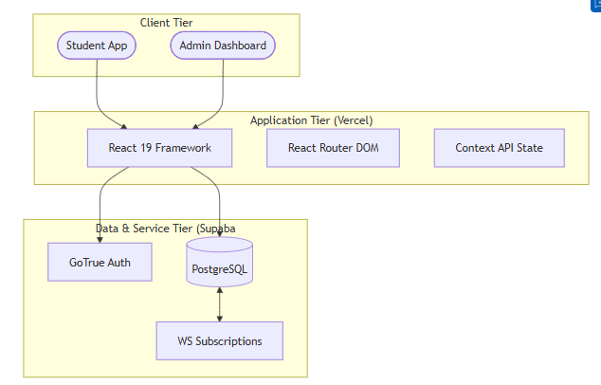

4.2 Use Case Diagram
The system serves two primary actors with distinct interaction paths:
- Student: Search Books, Book Seat, View ID/QR, Reserve Book.
- Admin: Manage Inventory, Approve Users, Reset Seat Map, Track Loans.

4.3 Data Flow Diagram (Level 0)
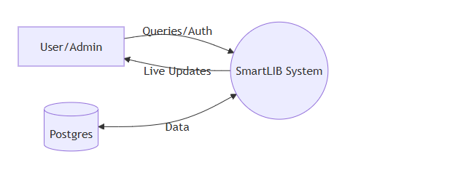

4.4 Entity Relationship (ER) Diagram
The database is designed with a highly normalized structure to ensure data consistency. The diagram below illustrates the relationships between the core entities:

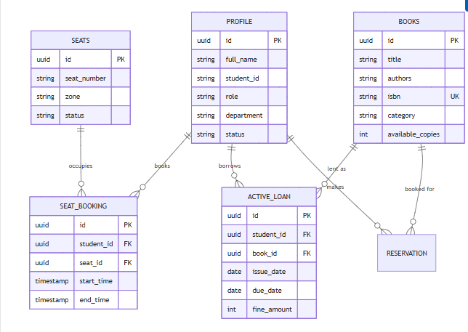

- Primary Keys (PK): Identified by unique UUIDs for all major entities.
- Foreign Keys (FK): Establish integrity (e.g., student_id in active_loan refers to id in profile).
- Unique Keys (UK): ISBN is constrained to be unique per book title.

4.5 AI Recommendation Logic
The system retrieves the student's department from their profile and performs a SQL contains query on the books table's departments array to suggest the most relevant academic resources.

CHAPTER 5: IMPLEMENTATION

5.1 Frontend Implementation
The frontend is built using React 19 and TypeScript.
- Atomic Components: Reusable UI elements like BookCard and SeatMap.
- Styling: Tailwind CSS with custom glass morphism effects.
- Animations: Framer Motion for smooth transitions between dashboard views.

5.2 Backend Implementation
Leveraging Supabase for a serverless backend:
- Authentication: JWT-based session handling via Supabase Auth.
- Real-time Sync: WebSocket channels for instant seat occupancy broadcasts.

5.3 Database & Security
- PostgreSQL: Normalized schema with automated triggers for inventory tracking.
- Row Level Security (RLS): Enforces privacy so students can only access their personal loan data while maintaining public read access to the book catalog.

5.4 Multilingual Implementation
Implemented via a custom Language Context mapping localization key to English, Hindi, and Kannada, persisted in local Storage.

CHAPTER 6: RESULTS AND OUTPUT SCREENS

6.1 Landing & Entry Flow
The landing page acts as the gateway for both students and staff.
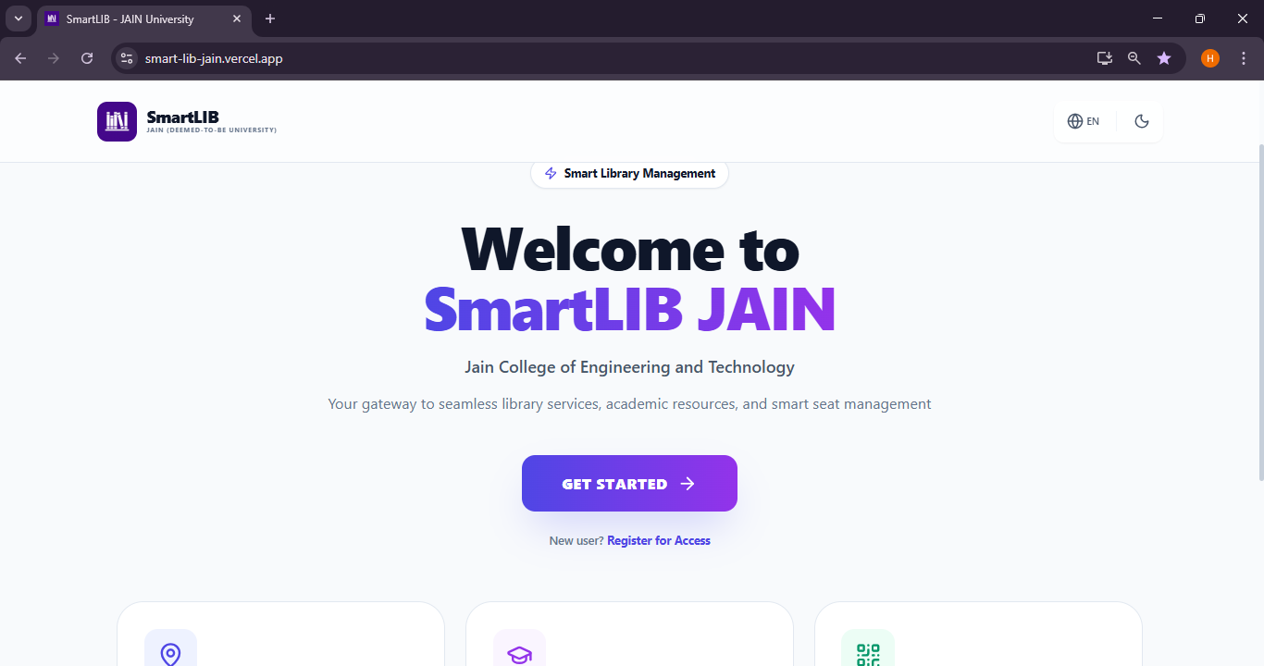

6.2 Authentication & Role Routing
The login interface handles both Student and Admin credentials.
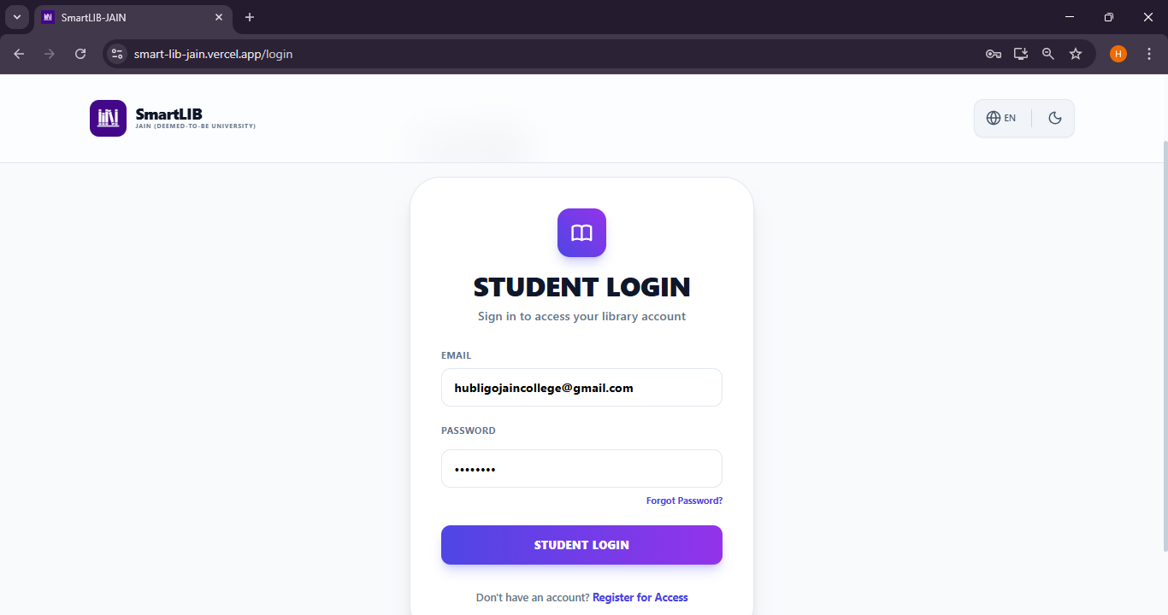

6.3 Student Dashboard & Real-Time Statistics
- Digital ID Card: A toggleable modal featuring a scannable QR Code for verified identity.
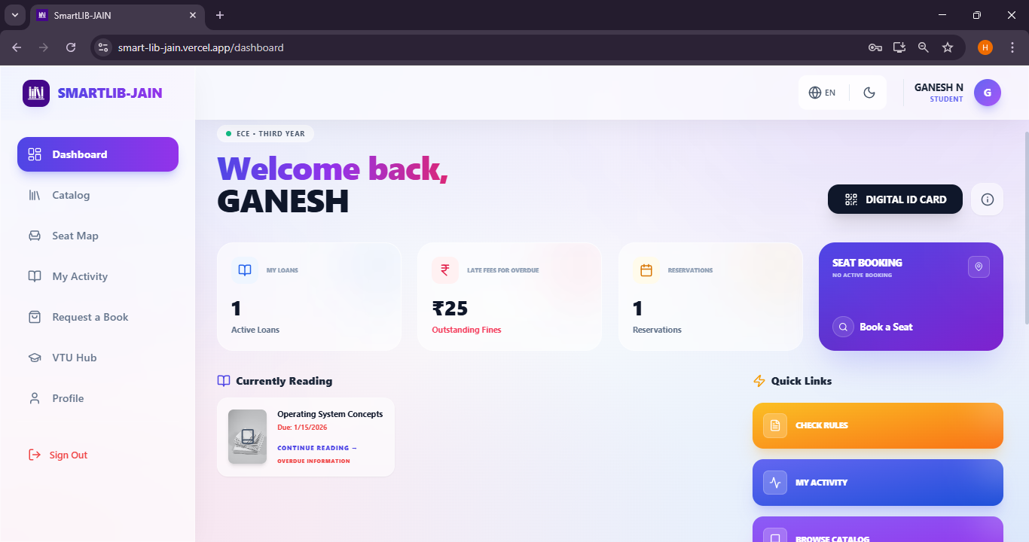
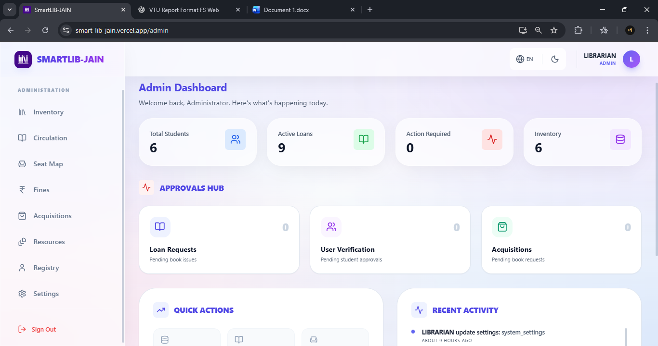
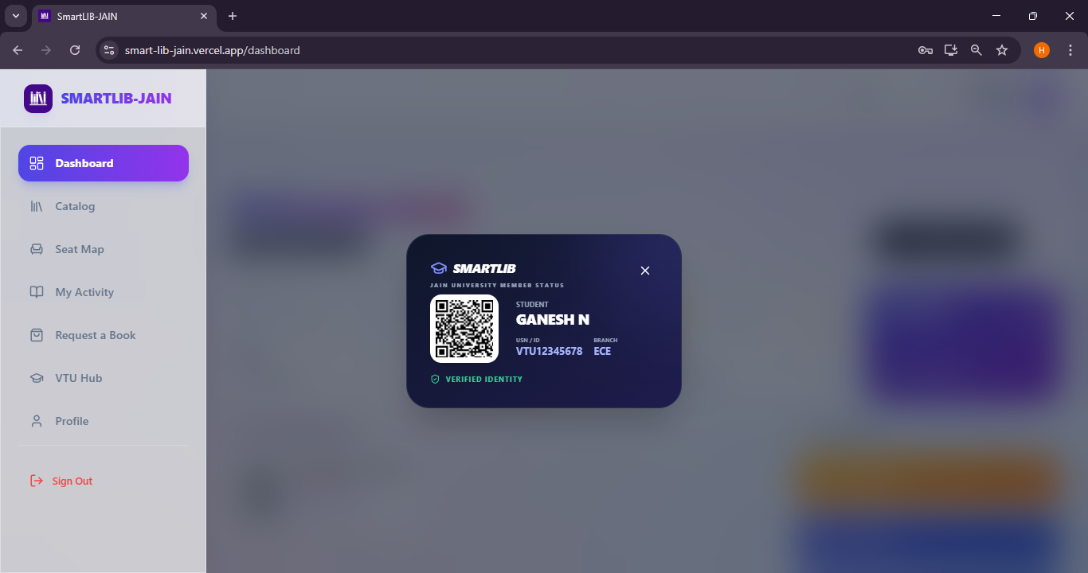

- AI Recommendation Carousel: Suggests books tailored to the student's curriculum (e.g., CSE-specific titles).
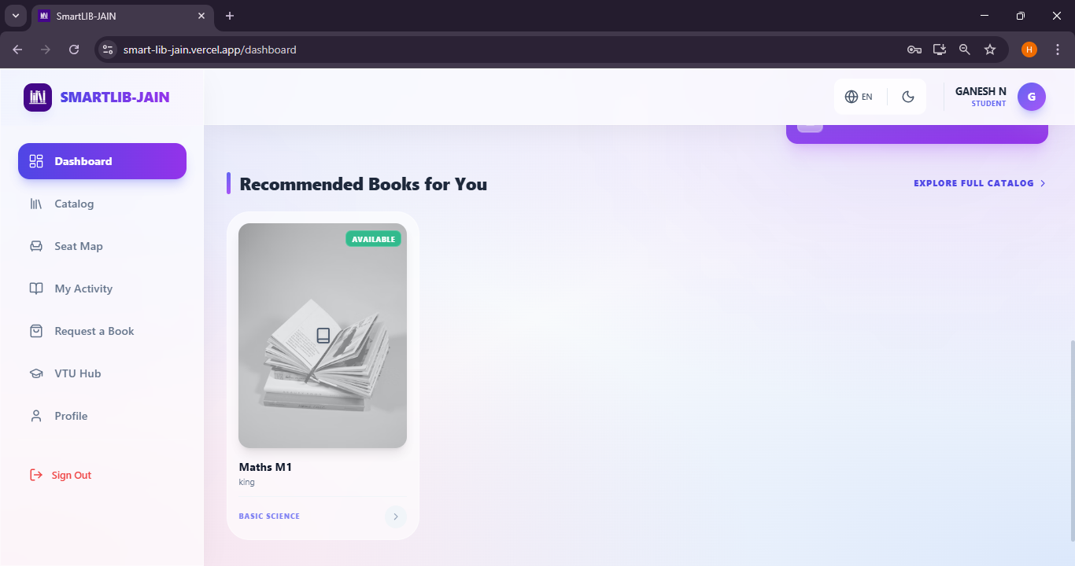

- Seat Map Preview: Shows real-time occupancy and booking timers.
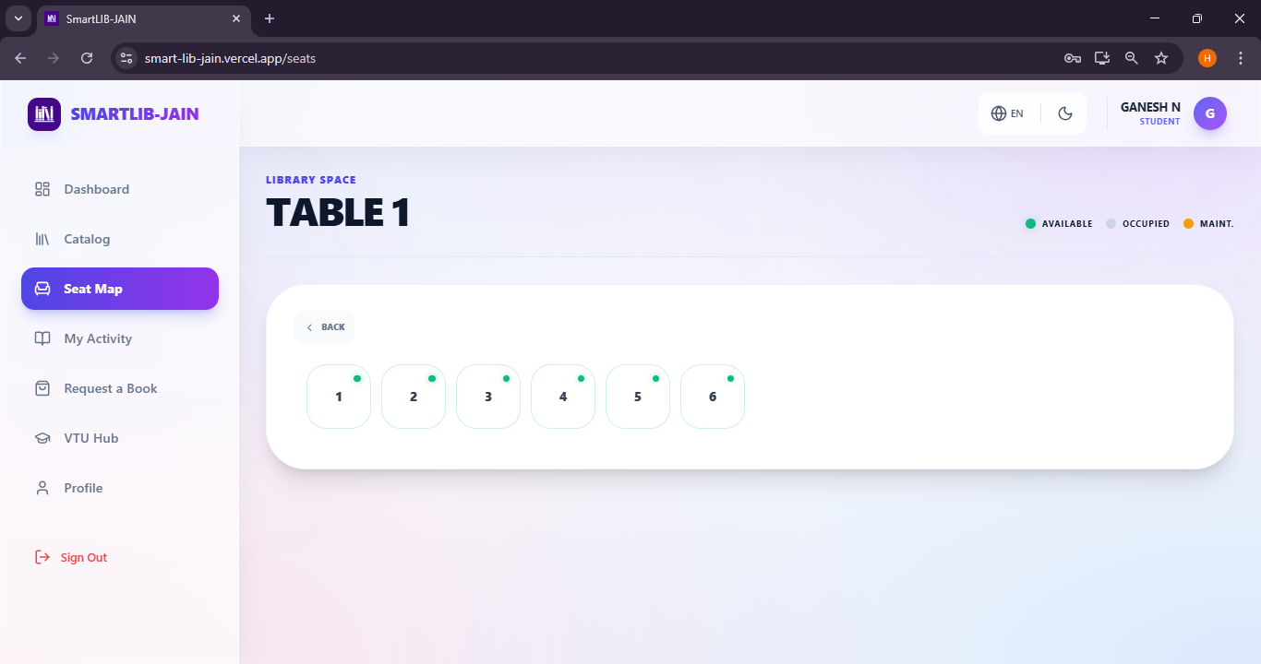
CHAPTER 7: TESTING

7.1 Testing Methodology

The validation of SmartLIB followed a multi-layered testing strategy to ensure reliability and data integrity:
- Unit Testing: Individual components such as Language Selector and Book Card were tested in isolation to verify correct rendering and property handling.
- Integration Testing: Verified the communication between the React frontend and Supabase backend. Specifically, we tested the "Seat Booking" flow to ensure that a database update correctly triggers a UI state change across multiple clients using WebSocket.
- Black-Box Testing (Functional): Focused on the user's perspective. Actions like "Reset Password" and "Book Request" were tested without considering the underlying code, ensuring the expected behavior occurred for the end-user.
- Security Testing (RLS Validation): A critical phase where we attempted to access administrative tables using a student session. We verified that Supabase Row Level Security (RLS) successfully blocked unauthorized requests at the database level.
- Performance Testing: Using Vite's build tools and Chrome DevTools to measure the First Contentful Paint (FCP) and ensuring the app loads in under 2 seconds on mobile devices.

7.2 Test Cases

ID | Test Scenario | Input | Expected Output | Actual Output | Status
TC1 | Role Verification | Student Login | Redirect to Dashboard | Redirect to Dashboard | Pass
TC2 | Fine Calculation | Overdue book | Computed fine value | Accurate Fine in ₹ | Pass
TC3 | Localization | Switch to Kannada | Text changes to KN | Text changes to KN | Pass
TC4 | Seat Timer | 15 min inactivity | Seat Auto release | Seat Auto release | Pass

CHAPTER 8: ADVANTAGES, LIMITATIONS & APPLICATIONS

8.1 Advantages
- Real-time Efficiency: Eliminates "seat camping" and manual seat tracking through live visibility and auto-expiry logic.
- Enhanced Security: Role-based access control and QR-based digital IDs prevent unauthorized library use.
- Localized Accessibility: Triple-language support ensures inclusivity for students from diverse linguistic backgrounds.
- User-Centric AI: Automated book recommendations save student time and improve curriculum engagement.
- Mobile Convenience: Cross-platform portability (Web + APK) allows students to book resources on the go.

8.2 Limitations
- Internet Dependency: The core real-time features (seat updates, AI recommendations) require an active internet connection to communicate with the Supabase cloud.
- Physical Integration: While the software is digital, physical hardware (QR scanners at library gates) is needed for full automation of the entry/exit process.

8.3 Applications / Use Cases
- University Libraries: Managing thousands of students and book circulation in large campus environments.
- Corporate Training Centers: Reserving rooms and resources for professional development modules.
- Public Libraries: Modernizing communal learning spaces with digital check-in and inventory tracking.
- Exam Centers: Allocating seats and managing hall tickets through the Digital ID system.

CONCLUSION & FUTURE ENHANCEMENT

Summary of Work Done
The project has successfully integrated real-time seat management, a multilingual catalog, and an AI-powered recommendation engine.

Future Improvements
- RFID-Based Asset Tracking: Integrating RFID hardware into the book collection to enable "Walk-through" checkout, where books are automatically registered to the student's ID as they exit the library.
- Predictive Library Analytics: Using machine learning to analyze historical booking data and predict "Peak Seating" hours, allowing students to plan study sessions more effectively via a "Heat Map" interface.
- Augmented Reality (AR) Indoor Navigation: Implementing an AR module in the Android APK to provide students with a "Digital Path" to the exact shelf and row where their requested book is located based on the library's location codes.
- AI-Driven Collaborative Study Matching: A system that anonymously matches students from similar departments who are currently in the library, facilitating peer-to-peer learning and collaborative research.
- IoT-Enabled Environment Control: Connecting the real-time seat map to the library's smart lighting and HVAC system to optimize energy efficiency by targeting active zones only.

REFERENCES

- React Team, “React 19 — blog,” React official blog, Dec. 5, 2024.
- “React — Versions,” React documentation.
- Supabase, “Row Level Security,” Supabase Docs.
- Supabase, “Realtime Protocol / WebSocket Realtime,” Supabase Docs.
- PostgreSQL Global Development Group, “Row Security Policies,” PostgreSQL Documentation.
- Tailwind Labs, “Tailwind CSS — Documentation,” Tailwind CSS official website.
- Motion (formerly Framer Motion) documentation, “Motion — JavaScript & React animation library.”
- D. J. Hardt et al., “RFC 7519 — JSON Web Token (JWT),” IETF, 2015.
- EmailJS, “Connect your email service / Documentation,” EmailJS Docs.
- M. C. Urdaneta-Ponte et al., “Recommendation Systems for Education: Systematic Review,” Electronics (MDPI), vol. 10, no. 14, 2021.
- “Educational Recommender Systems: A Systematic Literature Review,” ResearchGate (systematic review), 2023.
- J. Lu, “Recommender systems application developments: A survey,” Information Processing & Management, 2015.
- Q. Huang, “Intelligent Electronic Management of Library by Radio (RFID),” Data Science Journal / Proceedings, 2019.
- S. Bhalchakra, “Library Management System Based on RFID,” IJIRT (paper PDF), 2019.
- M. Dhahri, “A review of educational recommender systems,” ERIC / ED621312, 2021.

